**Character sequences.**

The string class has been briefly introduced in an earlier chapter. It is a very powerful class to handle and manipulate strings of characters. However, because strings are, in fact, sequences of characters, we can represent them also as plain arrays of elements of a character type.

For example, the following array:

|  |  |  |
| --- | --- | --- |
|  | char foo [20]; |  |

is an array that can store up to 20 elements of type char. It can be represented as:

https://www32.cplusplus.com/doc/tutorial/ntcs/c_strings1.png

Therefore, this array has a capacity to store sequences of up to 20 characters. But this capacity does not need to be fully exhausted: the array can also accommodate shorter sequences. For example, at some point in a program, either the sequence "Hello" or the sequence "Merry Christmas" can be stored in *foo*, since both would fit in a sequence with a capacity for 20 characters.

By convention, the end of strings represented in character sequences is signalled by a special character: the *null character*, whose literal value can be written as '\0' (backslash, zero).

In this case, the array of 20 elements of type char called *foo* can be represented storing the character sequences "Hello" and "Merry Christmas" as:

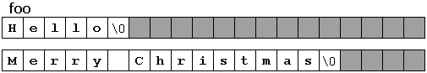

Notice how after the content of the string itself, a null character ('\0') has been added in order to indicate the end of the sequence. The panels in gray color represent char elements with undetermined values.